Quorum installation steps:---------

1)Download VirtualBox from the link: <https://www.virtualbox.org/wiki/Downloads> and proceed to install it on the system. After the installation, you must restart the system and should have a screen like the image below. Initially only the default machine will be available.

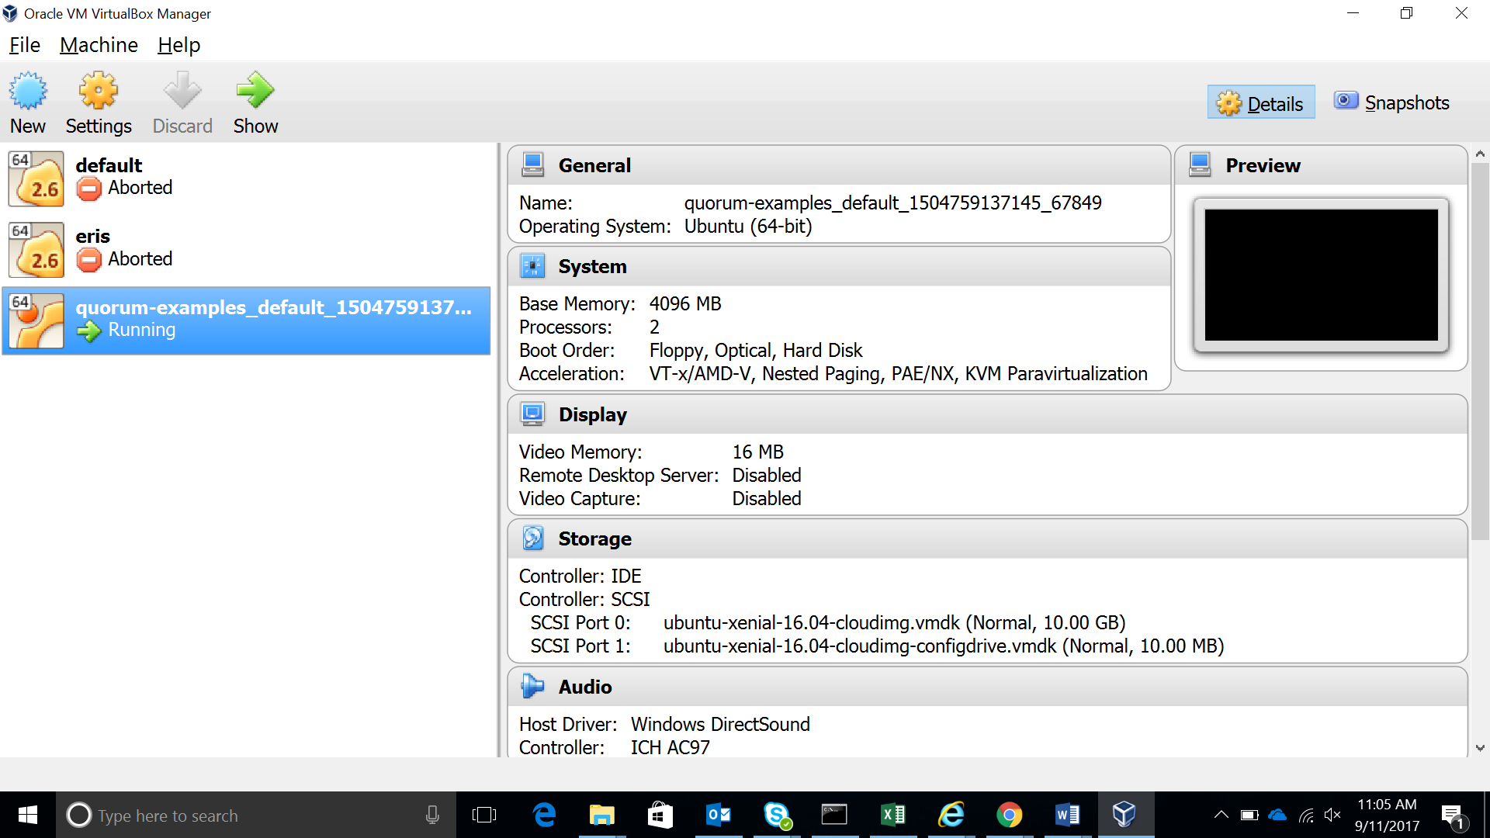

2)Next download Vagrant from the link: <https://www.vagrantup.com/downloads.html> and proceed to install it using the .exe file. Restart the system after a successful installation.

3)Open command prompt and type the following commands in sequence

->git clone https://github.com/jpmorganchase/quorum-examples

->cd quorum-examples

-> vagrant up (this step will take around 5 mins to download the required files)

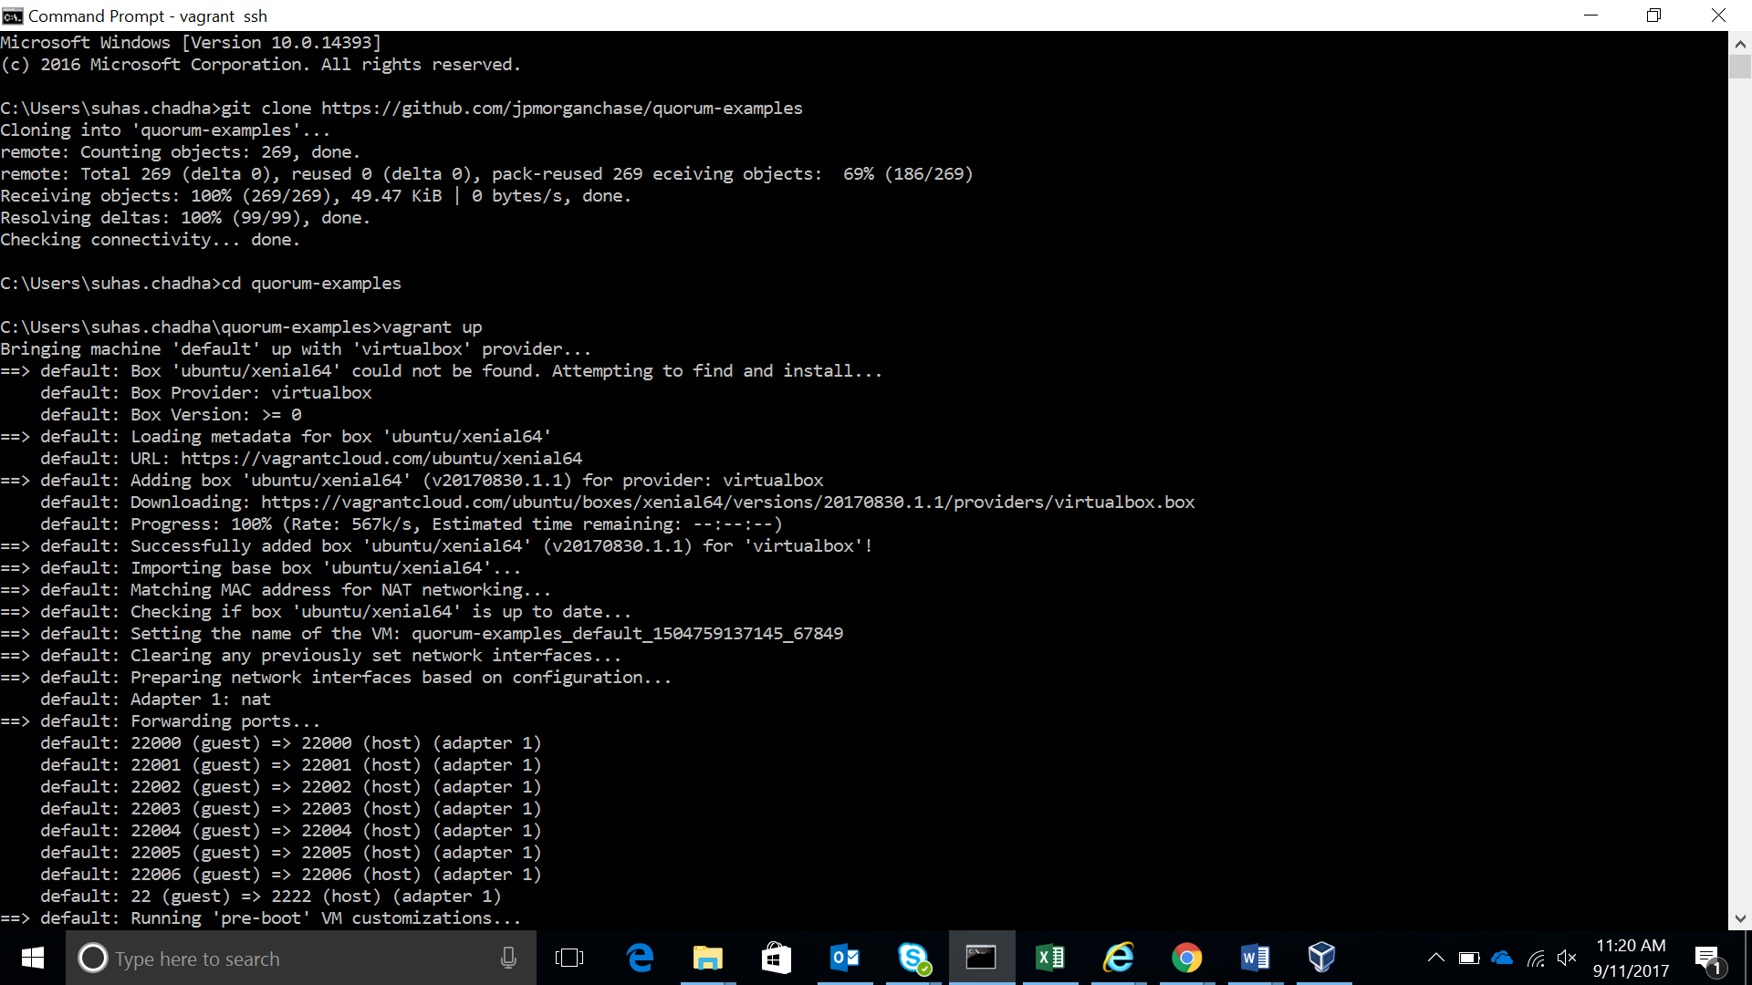

On successfully completing the installing you will be left with the following screen

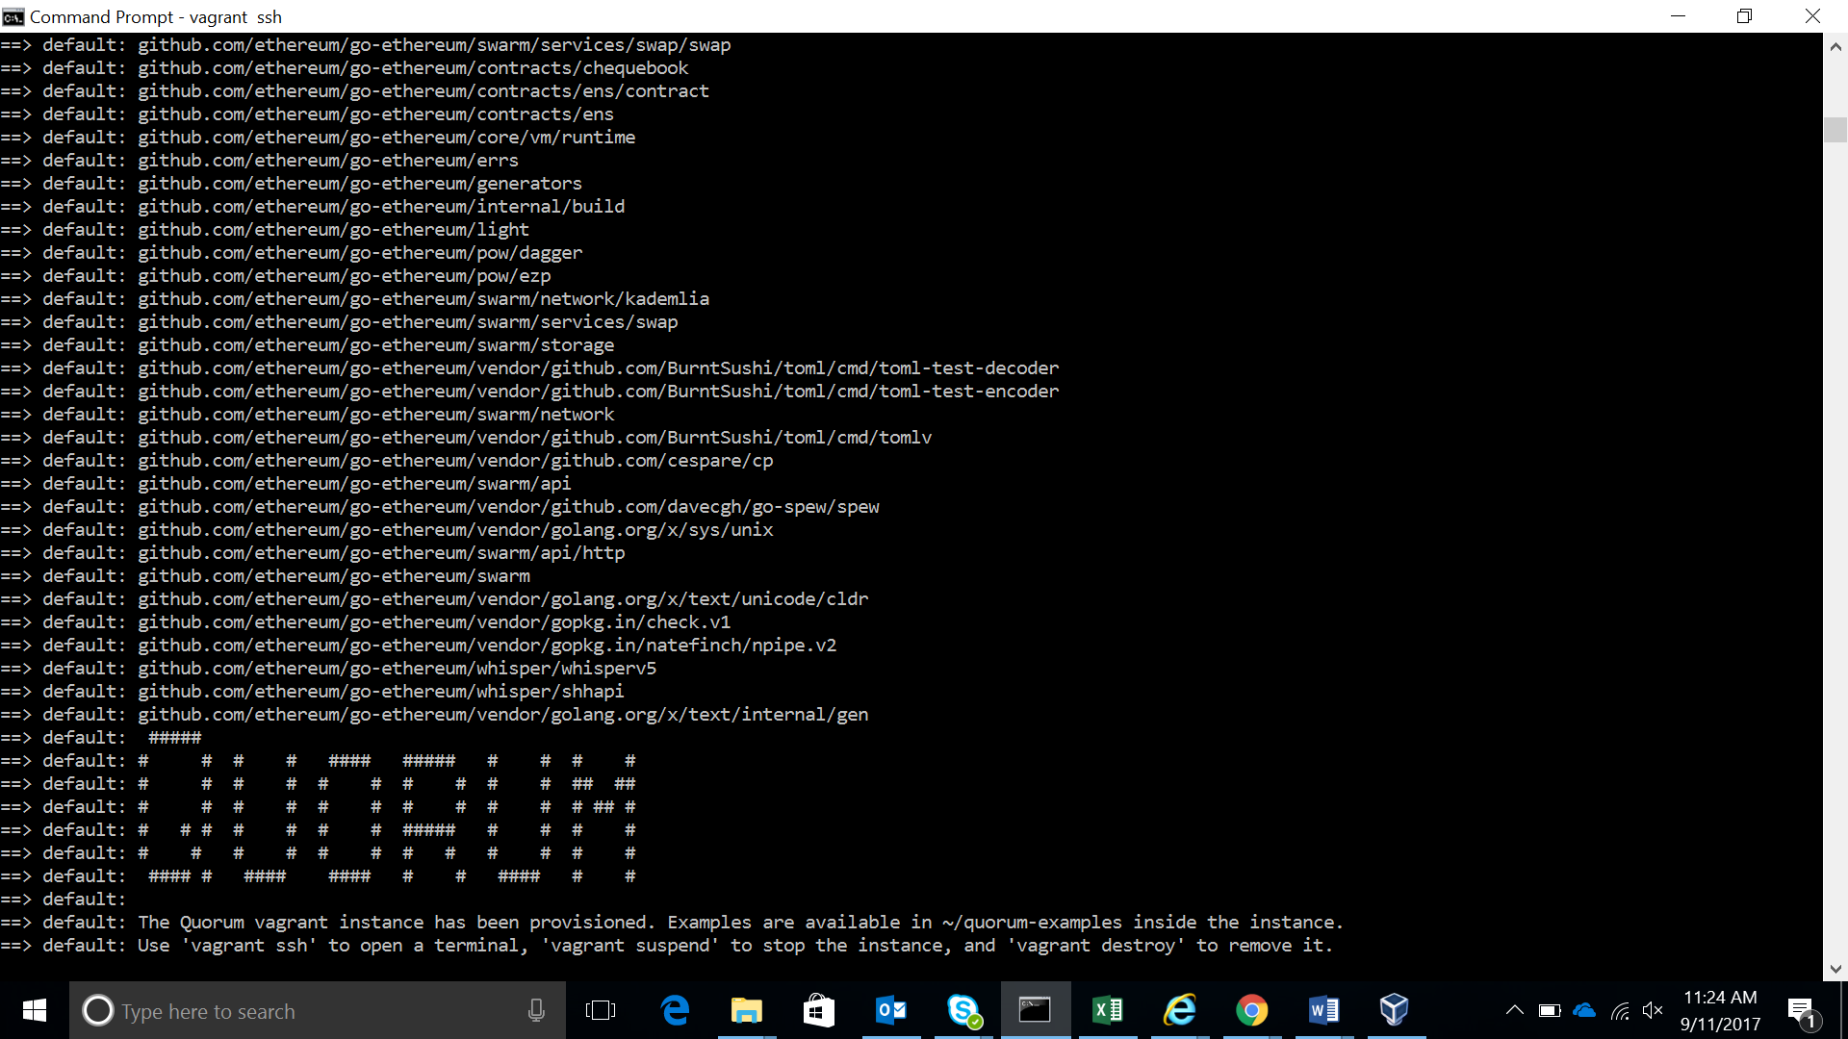

->vagrant ssh (To enter the terminal)

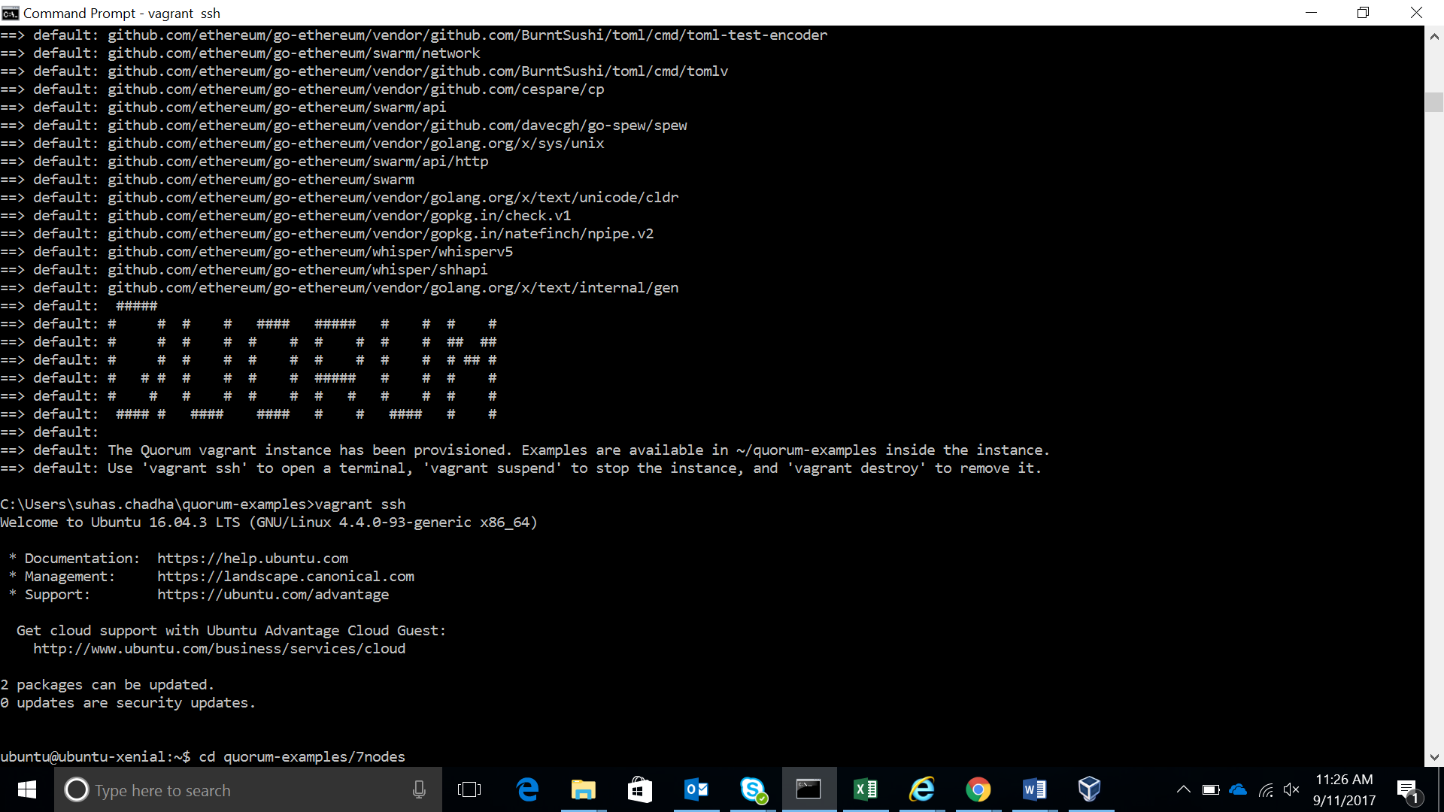

4) Now that the Quorum environment has been set up, the 7-node example cluster example provided by Quorum can be run. The following steps will help run the example:

i)After executing vagrant ssh, in the same terminal execute the command: cd quorum-examples/7nodes to enter the folder.

ii)./init.sh (Configures nodes)

iii)./start.sh (Starts constellation and boot node)

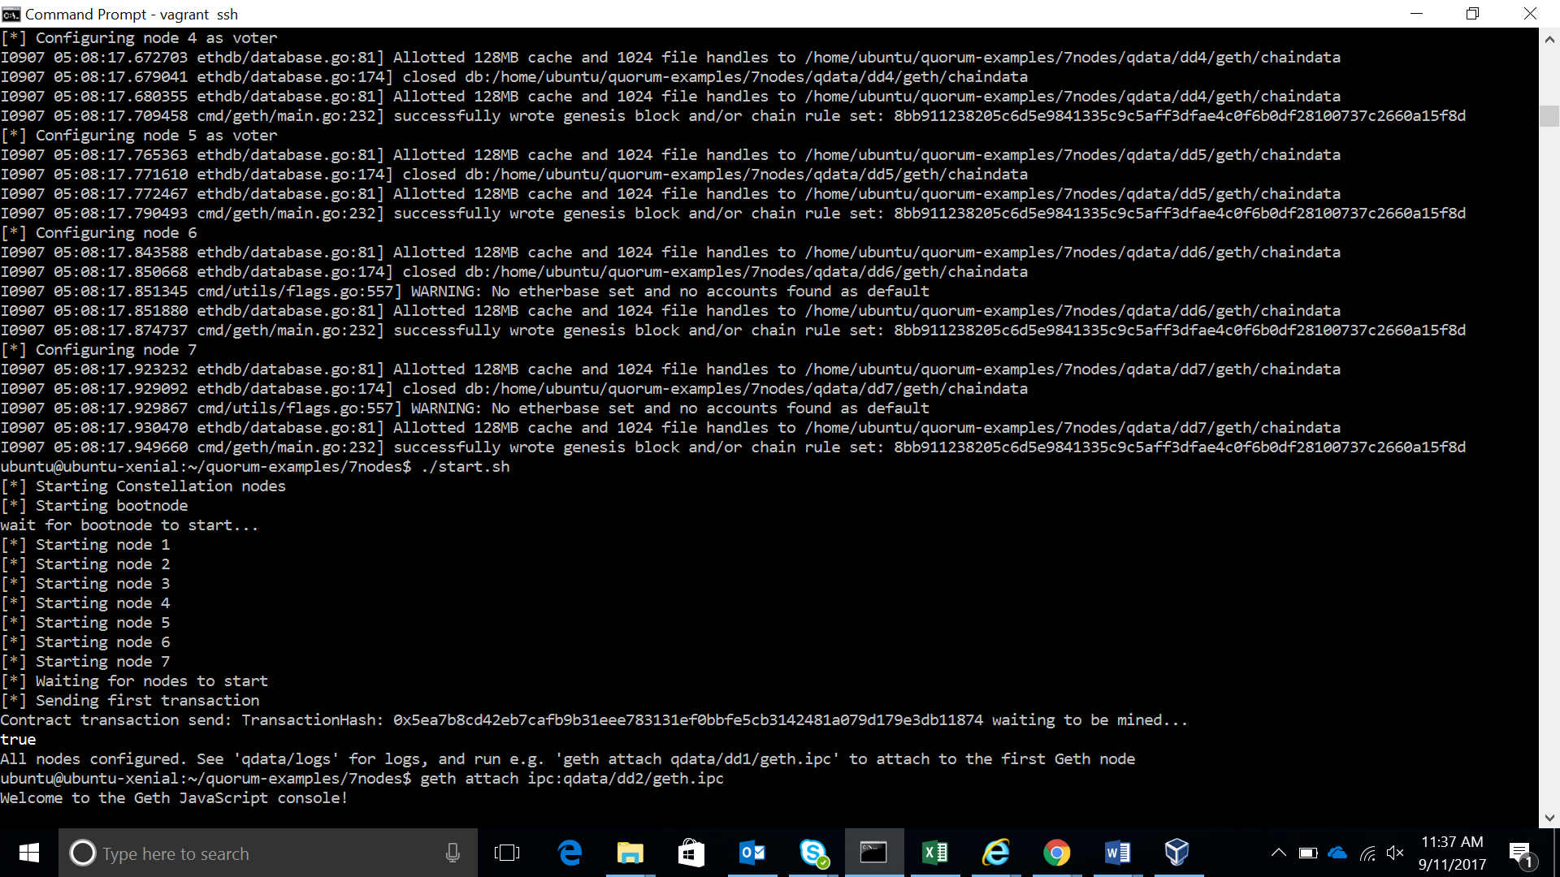

iv)Nodes can be connected and inspected using the commands:

-> $ geth attach ipc:qdata/dd1/geth.ipc (Note:change dd1 to dd2/dd3… for other nodes)

-> quorum.nodeInfo

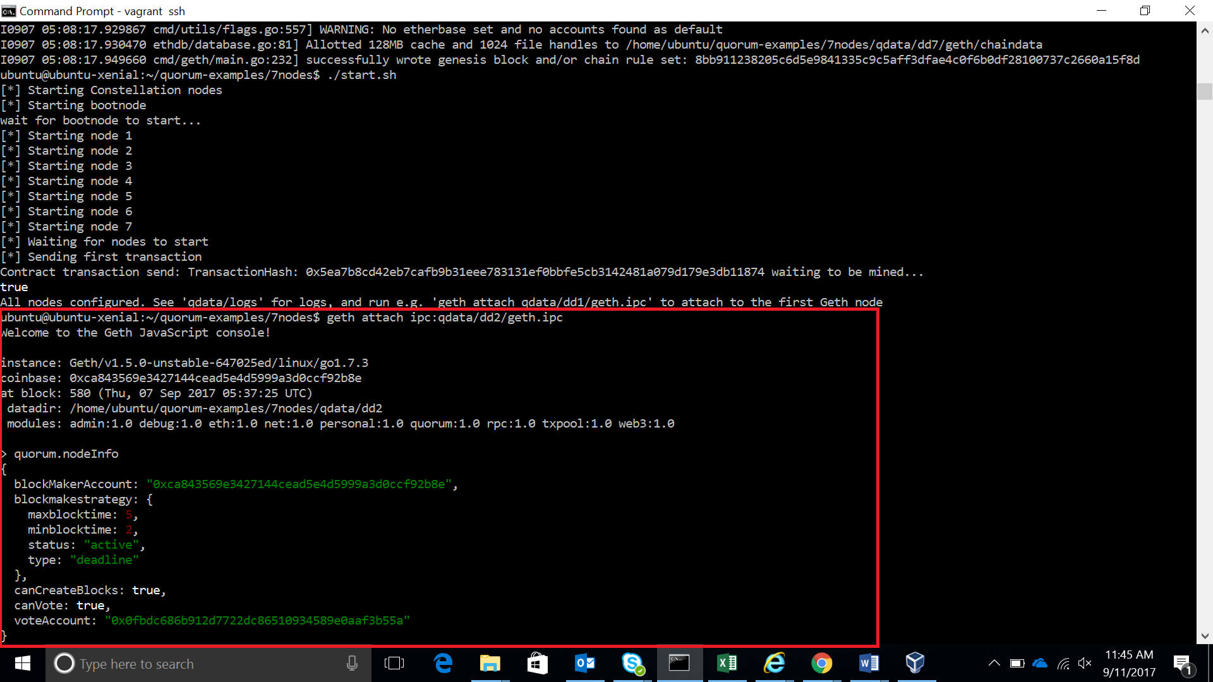

Reference:

<https://github.com/jpmorganchase/quorum>